# Status Report # 4

Report Date

February 5, 2016

Progress Overview

During this period we have successfully setup the databases outlined in the project design document. We’ve implemented this database using the PostgreSQL DBMS.

During this period we have all setup and begun to create a large part of the backend system API. The API currently supports basic system use such as login/logout, registration and getting user details.

During the period we also started to work on the client side application. Currently we have focus mainly on designing it’s UI components while we continue to work on the backend server API.

Budget Overview

## Cost Overview as of February 5, 2016

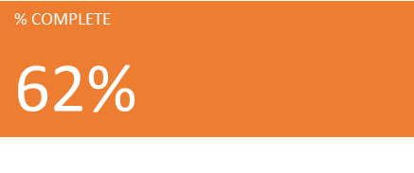

## Cost Status for all top-level tasks

## Cost Status for all top-level tasks

Outstanding Issues/Purposed Solutions

There are currently no issues to report.

Change Requests

There are currently no pending or active change requests.

Plans For Next Period

During the next period our goal is to mostly complete the backend server API so that we can start working on integrating the client side application and website with it.

We plan to continue work on the client side application, with the goal of having it communicating with our API and at a minimum handling user registration, login, and other user features.

We are planning to start work on our website in the next period as well. We’ll need to first complete endpoints in the API for it, but we plan to start the PHP code and design for it.